[ORGANIZATION NAME HERE]
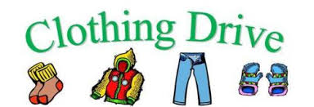
Fundraiser
[Date here] [Time here]
HELP SUPPORT OUR ORGANIZATION!
We will be collecting new or gently used men, women and children’s clothing, shoes, purses, belts, bed and bath linens and stuffed animals. Every piece helps! We can also accept bicycles and baby strollers.
NO Pillows, Books, Toys, Furniture, Appliances, or Household items. Thank you for your support!
Questions? Call [FUNDRAISER LEADER NAME HERE]

